**REPORT ON:**

**APPLICATION OF MODIFIED - DIMENSIONAL ANALYSIS FOR ESTIMATING COMPRESSIVE STRENGTH OF CONCRETE**

SUBMITTED TO THE VISHWAKARMA INSTITUTE OF INFORMATION TECHNOLOGY, PUNE

IN THE PARTIAL FULFILLMENT OF THE REQUIREMENTS FOR THE AWARD OF THE DEGREE

OF

**BACHELOR OF TECHNOLOGY (CIVIL ENGINEERING)**

PROJECT GUIDE: **Dr. (Mrs.) SHILPA V. PATIL**

**SUBMITTED BY:**

|  |  |  |  |
| --- | --- | --- | --- |
| **SR. NO.** | **NAME** | **GR. NO.** | **ROLL. NO.** |
| 1. | JAYESH SANTOSH KALE | 17U020 | 461024 |
| 2. | NIKHIL MUKUND PAWAR | 17U557 | 461032 |
| 3. | ABDULKADER K. MALPURWALA | 17U129 | 461001 |
| 4. | SHUBHAM GUJAR (TY STUDENT) | 21810749 | 313012 |



## DEPARTMENT OF CIVIL ENGINEERING

**BRACT’S**

**VISHWAKARMA INSTITUTE OF INFORMATION TECHNOLOGY**

SURVEY NO. 3/4, KONDHWA (BUDRUK), PUNE – 411048, MAHARASHTRA (INDIA).

**ACKNOWLEDGEMENT**

We express our sincere thanks and humble appreciation to **Dr. (Mrs.) Shilpa V. Patil,** Department of Civil Engineering, VIIT Pune, for her inspiring suggestions, whole hearted co-operation, constructive criticism and continuous encouragement in the preparation this project report, without which it would not have been in its present shape.

We would like to express our sincere thanks to the Director of VIIT and the other faculty members of Civil Engineering department for providing us the necessary facilities.

We would also like to thank non-teaching staff who helped us during our academic course work and project stages.

We also thanks to my friends who have helped us to shape our future at different stages of research work. Above all, we pay our regards to Almighty for love and blessings.

**SHUBHAM ARUN GUJAR**

**Exam Seat No.: 21810749**

**Roll No.: 313012**

**ABSTRACT**

Compressive strength is one of the most important mechanical properties which governs the structural health of an element. However, according to a standard cube testing procedure compressive strength of concrete can be identified or known only after 7,14 or 28 days. A Modified **-** Dimensional Analysis (M - DA) method for predicting compressive strength at 28 days for 6 mix proportions is presented in this paper, which would give an opportunity to end users, to track the compressive strength prior to 28 days which would enhance decision making for the construction. This method incorporates Modified Buckingham Pi theorem to formulate a general equation using maximum of 7 experimental results for mixed proportions containing water content, cement content, coarse aggregates, fine aggregates, fly ash, GGBS and super plasticizers and minimum of 4 experimental results for mixed proportions containing water content, cement content, coarse aggregates, fine aggregates. M – DA does not base it-self on any assumption or hypothesis, but relies on systematic grouping variables involved in a physical phenomenon to find dimensionless groups. A simultaneous solving of equations using Microsoft Excel Software was done to formulate general Dimensional Analysis equations. M – DA models are reliable to predict compressive strength at 28 days, as results of same were compared with experimental results for validation.

**CONTENTS**

|  |  |  |
| --- | --- | --- |
| SR. NO. | **DESCRIPTIONS** | **PAGE NO.** |
|  | *Certificate* | I |
| *Declaration* | II |
| *Acknowledgment* | III |
| *Abstract* | IV |
| *Contents* | V |
| *List of Figures* | VI |
| 1. | **INTRODUCTION** | **9-13** |
| 1.1. | General | 9 |
| 1.2. | Dimensional Analysis | 9 |
| 1.3. | Limitations of Dimensional Analysis | 10 |
| 1.4. | Buckingham Pi Theorem | 10 |
| 1.5. | Modified Buckingham Pi Theorem | 10 |
| 1.6. | Scope and Objective of Present Research Work. | 11 |
| 1.6.1. | Aim of Research Work | 11 |
| 1.6.2. | Objective of Research Work | 11 |
| 1.6.3. | Scope and Methodology of Research Work | 11 |
| 1.7. | Need for Research | 12 |
| 1.8. | Research Significance | 12 |
| 1.9. | Layout of The Dissertation Report | 13 |
| 2. | **LITERATURE REVIEW** | **14-16** |
| 2.1. | Introduction | 14 |
| 2.2. | Application of Modified – Dimensional Analysis | 14 |
| 3. | **METHODOLOGY AND EXPERIMENTAL INVESTIGATION** | **17-34** |
| 3.1. | Introduction | 17 |
| 3.2. | Flow Chart of Project | 17 |
| 3.3. | Mixed Proportions Used | 18 |
| 3.4. | Steps Executed for Formulation | 18 |
| 3.5 | Sensitivity Analysis | 19 |
| 3.6. | Data Collection | 34 |
| 4. | **RESULTS AND DISCUSSIONS** | **35 - 41** |
| 4.1. | Introduction | 35 |
| 4.2. | Results and Validation Through Statistical Parameters | 35 |
| 5. | **CONCLUSION** | **42 - 48** |
| 5.1. | Introduction | 42 |
| 5.2. | Key Observations from Sensitivity Analysis | 43 |
| 5.3. | Relationships Identified Between Concrete Ingredients and Compressive Strength of Concrete | 44 |
| 5.4. | Novelty of The Models Derived | 48 |
| 5.5. | Future Scope | 48 |
|  | **REFERENCES** | **49 - 50** |

**LIST OF FIGURES**

|  |  |  |
| --- | --- | --- |
| FIG. NO. | **DESCRIPTIONS** | **PAGE NO.** |
| 3.1 | Water/Cement Vs. Compressive Strength Measured | 19 |
| 3.2 | Fine aggregates/Cement Vs. Compressive Strength Measured | 20 |
| 3.3 | Fly ash/Cement Vs. Compressive Strength Measured | 20 |
| 3.4 | Coarse aggregates/Cement Vs. Compressive Strength Measured | 21 |
| 3.5 | Super Plasticizers/cement Vs. Compressive Strength Measured | 22 |
| 3.6 | Water/Cement Vs. Compressive Strength | 22 |
| 3.7 | Coarse aggregates/Cement Vs. Compressive strength | 22 |
| 3.8 | Fine aggregates/Cement Vs. Compressive strength | 23 |
| 3.9 | GGBS/Cement Vs. Compressive strength | 23 |
| 3.10 | Super Plasticizers/Cement Vs. Compressive strength | 24 |
| 3.11 | Water/Cement Vs. Compressive strength | 25 |
| 3.12 | Coarse aggregates/Cement Vs. Compressive strength | 25 |
| 3.13 | Fine aggregates/Cement Vs. Compressive strength | 26 |
| 3.14 | Super Plasticizers/Cement Vs. Compressive strength | 26 |
| 3.15 | Water/Cement Vs. Compressive strength | 27 |
| 3.16 | Coarse aggregates/Cement Vs. Compressive strength | 27 |
| 3.17 | Fine aggregates/Cement Vs. Compressive strength | 28 |
| 3.18 | Fly-ash/Cement Vs. Compressive strength | 28 |
| 3.19 | GGBS/Cement Vs. Compressive strength | 29 |
| 3.20 | Super Plasticizers/Cement Vs. Compressive strength | 29 |
| 3.21 | Coarse aggregates/Cement Vs. Compressive strength | 30 |
| 3.22 | Water/Cement Vs. Compressive strength | 30 |
| 3.23 | Fine aggregates/Cement Vs. Compressive strength | 31 |
| 3.24 | Water/Cement Vs. Compressive strength | 32 |
| 3.25 | Coarse aggregates/Cement Vs. Compressive strength | 32 |
| 3.26 | Fine aggregates/Cement Vs. Compressive strength | 33 |
| 3.27 | GGBS/Cement Vs. Compressive strength | 33 |
| 4.1 | Predicted Vs Measured (for result 1.) | 36 |
| 4.2 | Predicted Vs. Measured (for result 2.) | 37 |
| 4.3 | Predicted Vs. Measured (for result 3.) | 38 |
| 4.4 | Predicted Vs. Measured (for result 4.) | 39 |
| 4.5 | Predicted Vs. Measured (for result 5.) | 40 |
| 4.6 | Predicted Vs. Measured (for result 6.) | 41 |

**CHAPTER 1: INTRODUCTION**

* 1. **GENERAL:**

Concrete is the most commonly used building material. It is a versatile material that can be mixed easily to form any shape and assure a desired strength. In any type of concrete the compressive strength plays a very vital role for durability of component. Compressive strength prediction has been of utmost importance to construction industry because it tracks structural health of buildings, dams, etc. Moreover 28-day strength prediction is used as standard for checking quality of construction. Many efforts in past and present decade have been made to predict compressive strength of concrete. Concrete been a heterogeneous mixture, it has been a hustle to show a strong correlation between the mix proportion used and compressive strength at 28 days in a format. Many researchers used ANN, SVM, Multi – Regression Models, Fuzzy Logic, to predict compressive strength of concrete using mix proportion but, they lack rationality in input parameters, dimensional homogeneity and were not in nature. As a solution to this, M – DA tool can be used to overcome these problems and estimate compressive strength at 28 days.

* 1. **DIMENSIONAL ANALYSIS:**

Dimensional Analysis (DA) is a mathematical technique which deals with the dimensions of the physical quantities involved in the phenomenon. It is based on the assumption that the phenomenon can be expressed by a dimensionally homogenous equation with certain variables. By DA, the functional relationship between dependent and non-dependent variables can be expressed into dimensionless terms. In this methodology, it reduces the number of variables into 3 numbers. The unit of physical quantities which does not depends on the unit of any other physical quantities is called as fundamental dimensions (e.g., Mass, Length, Time). The unit of physical quantities which depends on the unit of any other physical quantities is called as derived of secondary dimensions (e.g., Force = Mass*Acceleration) [*P.N. Modi and S.M. Seth, 1960*].

* 1. **LIMITATIONS OF DIMENSIONAL ANALYSIS:**

1. The consequence of incorporating too many (or too few) in analysis, most of them do not provide clear, generally applicable alternative formulation.
2. Dimensional space used cannot be used reduced i.e. m remains constant depending upon involvement M, L, T so there is no equilibrium formulation which denotes rational philosophy.
3. Precise specifications of dimensionless groups governing problems, in which some key variables have either identical dimensions or none dimensions.
4. Restriction on selecting of m from only primary terms.
   1. **BUCKINGHAM PI THEOREM:**

Buckingham Pi Theorem states that, “If there are *n* variable (dependent and independent variables) in a dimensionally homogenous equation and if these variable contain *m* fundamental dimensions (M, L, T) then the variables are arranged into (n-m) dimensionless terms. These dimensionless terms are called as Pi terms”. [*P.N. Modi and S.M. Seth, 1960*].

* 1. **MODIFIED BUCKINGHAM PI THEOREM:**

Modified Buckingham’s-Pi theorem stated by R. Butterfield in 1999 [*Butterfield, 1999*] overcomes the limitations of Buckingham’s-Pi theorem, by introducing secondary dimensionless terms which are formed by combinations of fundamental terms (not necessary 3). Hence increasing the total (n-m) dimensionless terms, and give more rational algorithm. *R. Butterfield* first principle states that there will always be a minimum set Dmin of separate identifiable, non-zero dimensions, including secondary dimensions which can define all components of V. This tool has innumerable application in various of engineering sectors. We are going to apply this tool in Civil Engineering, to calculate the compressive strength of concrete. In our project, different mixes of concrete are obtained from various sources of several grades from various research papers, actual RMC data, lab data, etc. and they are sorted in excel sheet according to grades and few equations were generated to calculate compressive strength of concrete.

* 1. **SCOPE AND OBJECTIVE OF PRESENT RESEARCH WORK:** 
     1. **Aim of Research Work:**

To formulate a formulation for 6 mix proportion which can be used as a tool for understanding behaviour of concrete for each mix proportion and predicting compressive strength of concrete at 28 days.

* + 1. **Objective of Research Work:**

1. To understand the mechanical property that is, compressive strength of concrete for 6 mix proportions at 28 days.
2. To get relationship between ingredients used in concrete and compressive strength at 28 days.
3. To ensure dimensional homogeneity in each of formulation proposed.
4. To ensure a rational relationship between input and output parameters.
5. To reduce the total time for training the model.
6. Proposing a user-friendly equation for construction industry.
   * 1. **Scope and Methodology of Research Work:**
7. Understanding the objectives and scope of the project.
8. Collection of data from various data sources and literature reviews.
9. Sorting the data according to mix proportions and source.
10. Sensitivity analysis of *Pi* terms with respect to compressive strength for each mix proportion to determine the weightage of each of the *Pi* term.
11. Carrying out M – DA for each mix proportion.
12. Testing and validating the 6 equations.
13. Conclusions for from the experimentations results.
    1. **NEED FOR RESEARCH:**

Concrete being the most important member to get an insight on structural health of a building, dam, etc., the concrete strength can be understood only at 28 days. So, there is a hustle for an engineer to make an informed decision regarding further construction process before 28-days on site. There is a lot of literature for compressive strength prediction but there is a research gap between a formulations and dimensional homogeneity. As a result, there is a need for a formulation for different mix proportions, which would evaluate 28-day strength.

* 1. **RESEARCH SIGNIFICANCE:**

The formulation of 6 mix proportion highlights the material properties contributing towards compressive strength at 28-days. The proposed method can track structural health of element. Which proves to be an eminent factor in decision making for practicing engineers. To achieve this goal, we formulated 6 equations using minimum of 4 and maximum of 7 data set points in given mix proportions. The material behaviour was monitored which contributed towards compressive strength of concrete and was validated with experimental results from 10 sources.

* 1. **LAYOUT OF THE DISSERTATION REPORT:**

The dissertation report has been organized in six chapters. In the First Chapter the scope and objectives of research work have been presented.

In **Second Chapter**, a comprehensive and critical review of the relevant literature justifying the objectives of the research work and detailed information about Non-destructive techniques are presented.

**Chapter Three** explains methodology of project work along with the details of material used. details of mix design and experimental setup.

**Chapter Four** deals with the results obtained from the entire experimental work and discussions made on these results.

**Chapter Five** summarizes the entire work. The conclusions drawn from the

investigation is reported in this chapter.

**SUMMARY**

General information of project is explained in this chapter. Need, significance, scope, aim, and objectives of the research have been described.

**CHAPTER 2: LITERATURE REVIEW**

* 1. **INTRODUCTION:**

Objective of this chapter is to review existing literature for application of Modified – Dimensional Analysis. There is no extensive work done on application of Modified – Dimensional Analysis related to Concrete Technology. The current work is based on *R. Butterfield, 1999* research paper where he proposed Modified Buckingham Pi Theorem. Since then, many models for prediction of various output parameters such as ultimate load capacity of conical and pyramidal shells of foundations (*D. Esmaili and N. Hataf., 2013*). The load - settlement for spread footing in sand (*D.R. Phatak and H.B. Dhonde., 2000*). Ultimate tortional strength of reinforced concrete beams (*D.R. Phatak and H.B. Dhonde., 2003)*. 28-days compressive strength of 53 grade cement (*D.R. Phatak and N.P. Deshpande., 2005)* have been done by the researchers.

* 1. **APPLICATION OF** **MODIFIED – DIMENSIONAL ANALYSIS:**

There are basic principles rules for formulating the equation M – DA [*R. Butterfield., 1999*].

1. There will be always minimum set Dmin of separate identifiable, non-zero dimensions including secondary dimensions which can define all components of V. where V is set of dependent and independent variables.
2. Second requirement comes out, a set of variables Q = (Q1, Q2, Q3,...,Qn) with *m* elements need to be selected from V such that components of Q cannot themselves formed into dimensionless groups. Q then becomes ‘*repeated variables*’ in the analysis. Consequently, cannot contain –
   1. Variables which have identical dimensions.
   2. Variables which have no dimension.
   3. Variables which are or have dimensions which are power of one of others.
3. It is therefore helpful to introduce a list of R’s, the set of variables of V, which all have dimensions totally distinct from each other. Consequently, Q has to be selected from R.

The detailed literature for this method of Modified – Dimensional Analysis is presented as below:

**D.R. Phatak and H.B. Dhonde (2000)** presented a discussion using Modified – Dimensional Analysis to predict load settlement characteristic of 5 large spread footings in sand. They formulated the load settlement using only 2 experimental results. A unique trial and error procedure is demonstrated that generates universal dimensional analysis formulation, where in one of the experimental data set called the control point generates the Modified – Dimensional Analysis equation, while the other data sets, the check point, is used to validate the already formed dimensional analysis equation. The discussers made a comparison between the results predicted by Modified – Dimensional Analysis and actual experimental results, where they yield a reliable result for load settlements.

**D.R. Phatak and H.B. Dhonde (2003)** presented a paper on dimensional analysis of reinforced concrete beams subjected to pure torsion. Which was a detailed comparison between the results generated through Modified – Dimensional Analysis technique and experimental results carried out by *Hsu T.T.C* in *1968 a*, *1968 b.* The main objective was to predict ultimate torsional strength (*Tu*) using other parameters, index of longitudinal reinforcement, index of transverse reinforcement, uniaxial compressive strength of concrete, torsional plastic inertia of section. The results calculated through by the authors had standard deviation of 0.13 from the actual experimental results.

**D.R. Phatak and N.P. Deshpande (2005)** used dimensional analysis to predict 28-days compressive strength of 53 grade cements. They calculated compressive strength using parameters such as grade of cement, consistency, final setting time, initial setting time. They also used a trial-and-error method as stated in previous discussion (*D.R. Phatak and H.B. Dhonde. 2000*). The results generated were in parameter of average of experimental/calculated, which was 1.01. which was reliable.

**D. Esmaili and N. Hataf (2013)** presented a paper on determination of ultimate load capacity of conical and pyramidal shell foundations using dimensional analysis. They used simultaneous regression solving to solve 5 simultaneous equations. In this method ultimate load capacity was predicted through experimentation as well as dimensional analysis. The parameters used for formulation dry unit weight of sand, angle of sheering resistance, relative density of sand, height and dimension of soil core, thickness of shear models. The results yield was compared with 4 examples to validate.

**M. Corrade *et al.* (2009)** used a same technique for over-reinforced concrete beams in bending. They proposed a numerical algorithm for prediction mechanical behaviour of plastic hinges taking place in RC beams at ultimate loading conditions. They introduced overlapping crack model, based on non-linear fracture mechanics concepts, to describe concrete crushing, along with well-known cohesive crack model in tension and a stress versus crack opening displacement relationship for steel reinforcement. As a result, a new practical designed diagram was proposed for an improvement for current codes for practice, which complete disregards size-scale effects. Dimensional analysis was used to reduce complexities and make algorithm more simplified.

**Data Set Availability:** *Tuan Ngyen and Tuan Ngo (2018), Rachel Cook (2019), Dr. Salim T. Yousif and Salwa M. Abdullah (2009), Musbah Guma Musbah et.al (2019), Rajiv Banarjee et.al (2015), Sangjun Park (2012), Yong-Hyok Kim et.al (2020), Z. Wadud and S. Ahmad (2001), IS 10262 (2019), Database from Shree Ganesh Laboratory Satara, Maharashtra (2019)*

**SUMMARY**

This chapter presents detailed information of techniques, facts concerning the efforts done by different persons, methods recognized, in addition to growth in the study field of Modified – Dimensional Analysis. Methodology and detailed experimental set up of present work is explained in next chapter.

**CHAPTER 3: METHODOLOGY AND EXPERIMENTAL INVESTIGATION**

* 1. **INTRODUCTION:**

This chapter describes the entire experimental work of the project. Various materials used in each mix proportions in detail. Sensitivity analysis of the Pi terms, with respect to compressive strength of concrete and sources of the data sets.

* 1. **FLOW CHART OF PROJECT:**

* 1. **MIXED PROPORTIONS USED:**

1. Water content, cement content, coarse aggregates, fine aggregates, fly ash, super plasticizers
2. Water content, cement content, coarse aggregates, fine aggregates, GGBS, super plasticizers
3. Water content, cement content, coarse aggregates, fine aggregates, super plasticizers
4. Water content, cement content, coarse aggregates, fine aggregates, fly ash, GGBS, super plasticizers
5. Water content, cement content, coarse aggregates, fine aggregates
6. Water content, cement content, coarse aggregates, fine aggregates, GGBS
   1. **STEPS EXECUTED FOR FORMULATION:**
7. V= (a, b, c…. n) where (n=values)
8. Set of dependent parameters = (p, q, r..); Set of independent parameters=(w,s,t,u)
9. Incorporating secondary fundamental terms, Selection of R= (p,q,r…) where each parameter has different unit
10. Selection of Q (m terms) from R, many times are combination nC1, nC2, .......nCn
11. Determination of n-m pi terms, and determining Π1, Π2, …….Πn
12. Dimensionless Π terms can themselves be expressed in relation of dependent and independent parameters.
13. Taking number of data set points equal to number of unknown in above phenomenon and creating number of equations desired.
14. Solving these equations simultaneously using Microsoft Excel Software (Excel Solver).
15. Formulating an equation using values derived from step – viii.
    1. **SENSITIVITY ANALYSIS:**

Sensitivity Analysis was carried out for each of the mix proportion separately, with respect to compressive strength. This task was performed to understand the trend of each pi groups for each mix proportion. The pi terms are calculated as per mentioned in section **3.4. step – v**, because these pi terms act as an input parameter in prediction of compressive strength of concrete. In each of the graphs, best fit curve method was used to understand the relation between pi term used and compressive strength (e.g.: water/cement i.e., pi term Vs compressive strength).

1. **Mix proportion containing water content, cement content, coarse aggregates, fine aggregates, fly ash, super plasticizers-**

**Fig No. 3.1 (Water/Cement) Vs Compressive Strength Measured**

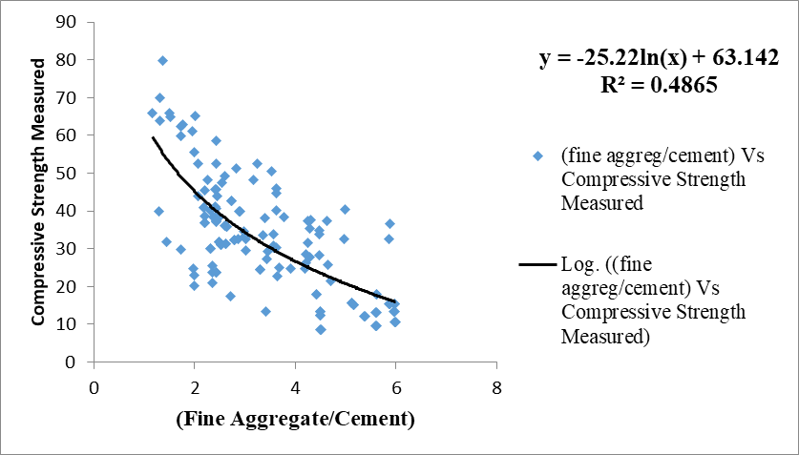

**Fig No. 3.2 (Fine Aggregate/Cement) Vs Compressive Strength Measured**

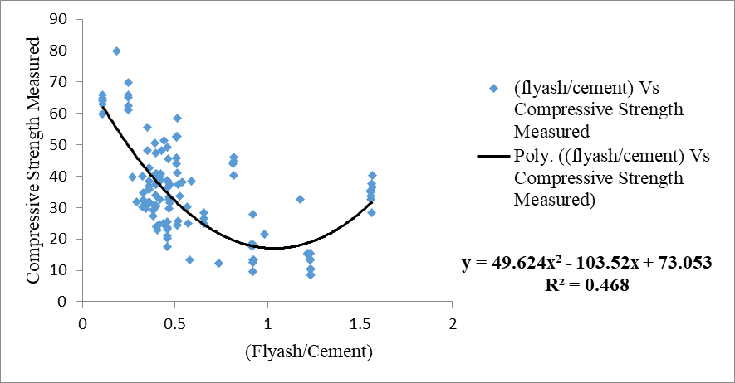

**Fig No. 3.3 (Fly ash/Cement) Vs Compressive Strength Measured**

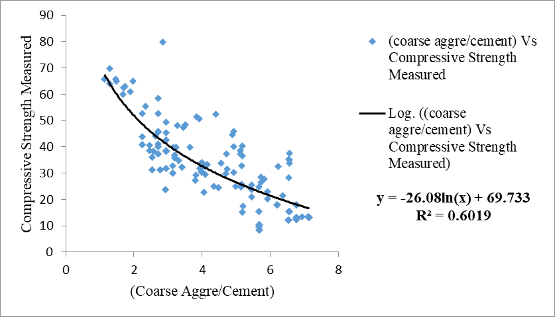

**Fig No. 3.4 (Coarse Aggregate/Cement) Vs Compressive Strength Measured**

**Fig No. 3.5 Super plasticizers/cement Vs Compressive Strength Measured**

1. Mix proportion containing water content, cement content, coarse aggregate,

fine aggregates, GGBS, super plasticizers-

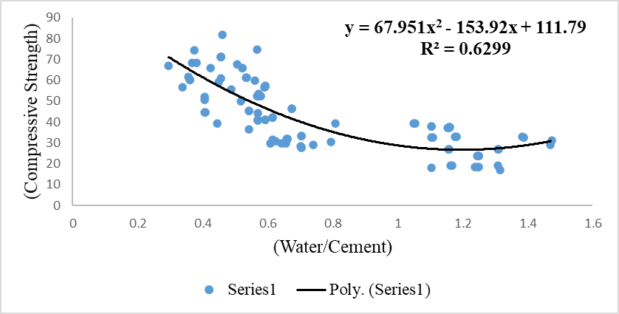

**Fig No. 3.6 (Water/Cement) Vs. (Compressive Strength)**

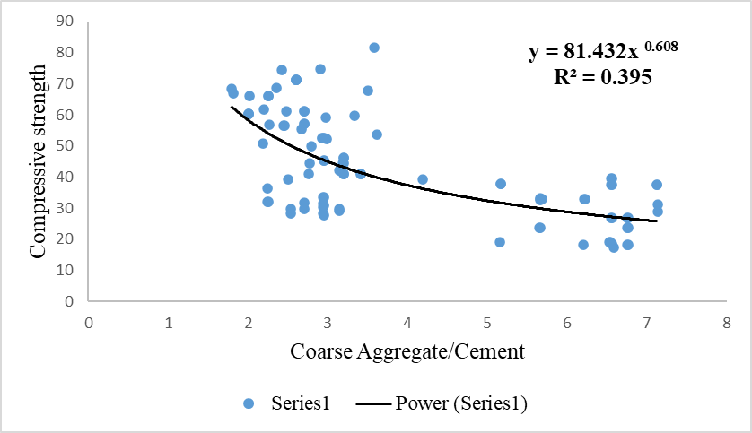

**Fig No. 3.7 Coarse Aggregate/Cement Vs. Compressive strength**

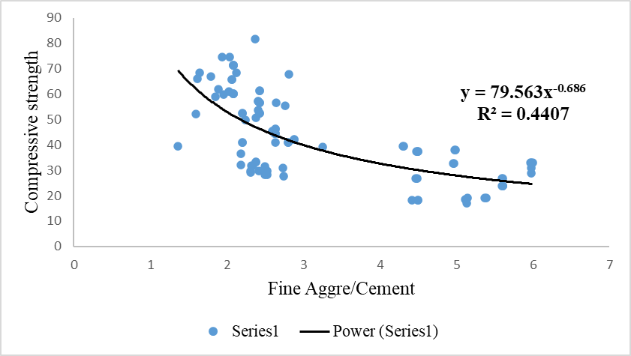

**Fig No. 3.8 Fine Aggregate/Cement Vs. Compressive strength**

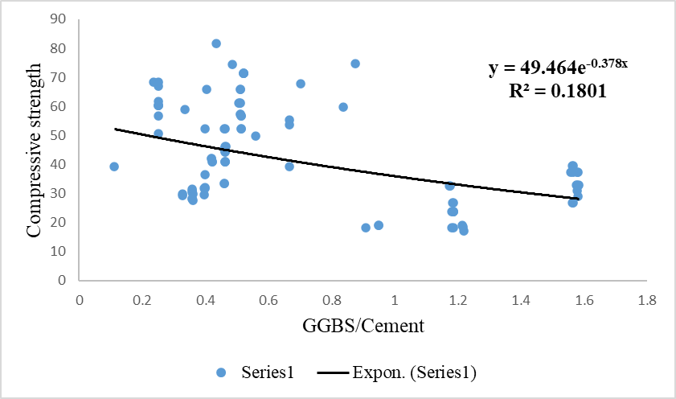

**Fig No. 3.9 GGBS/Cement Vs. Compressive strength**

**Fig No. 3.10 Super Plasticizers/Cement Vs. Compressive strength**

1. Mix proportion containing water content, cement content, coarse aggregates, fine aggregates, Super plasticizers –

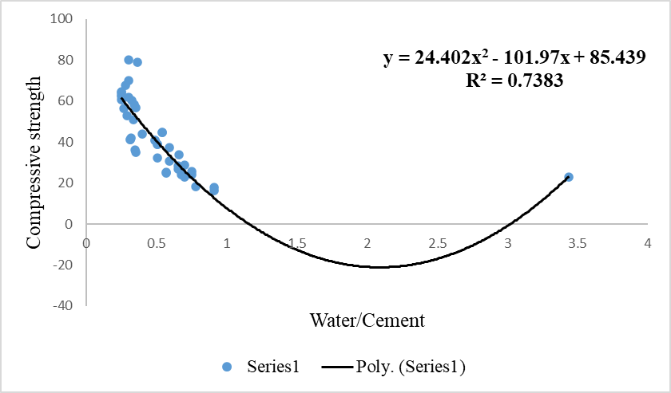

**Fig No. 3.11 Water/Cement Vs. Compressive strength**

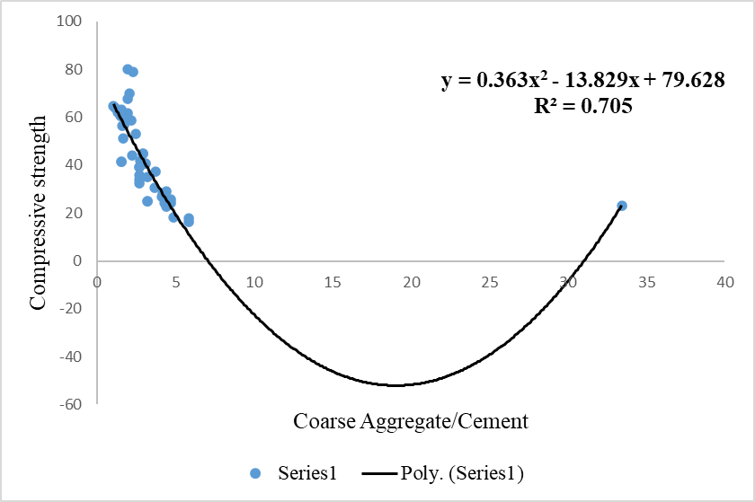

**Fig No. 3.12 Coarse Aggregate/Cement Vs. Compressive strength**

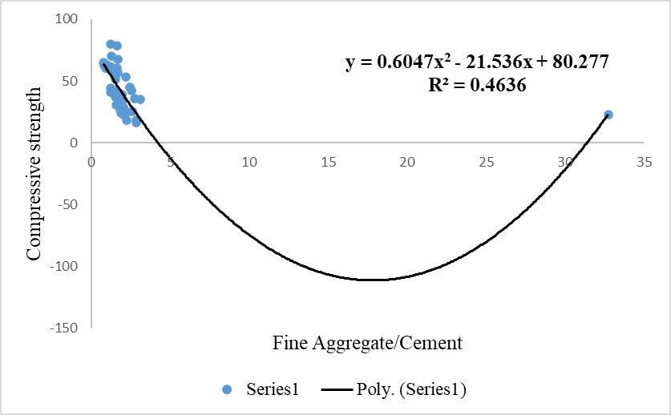

**Fig No. 3.13 Fine Aggregate/Cement Vs. Compressive strength**

**Fig No. 3.14 Super Plasticizers/Cement Vs. Compressive strength**

1. Mix proportion containing water content, cement content, coarse aggregates, fine aggregates, fly ash, GGBS, super plasticizers –

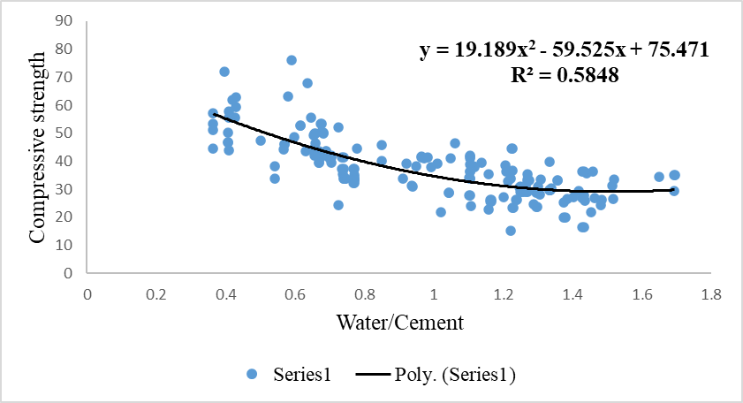

**Fig No. 3.15 Water/Cement Vs. Compressive strength**

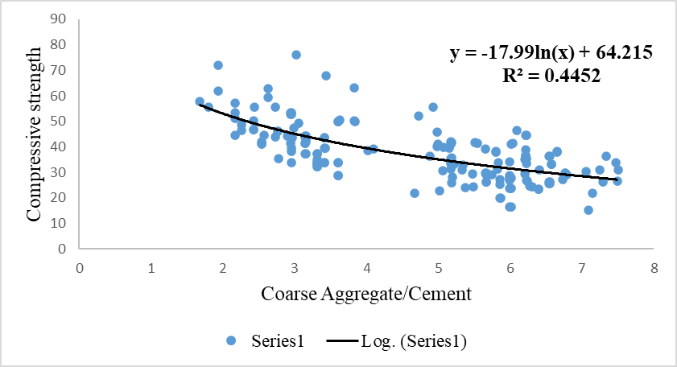

**Fig No. 3.16 Coarse Aggregate/Cement Vs. Compressive strength**

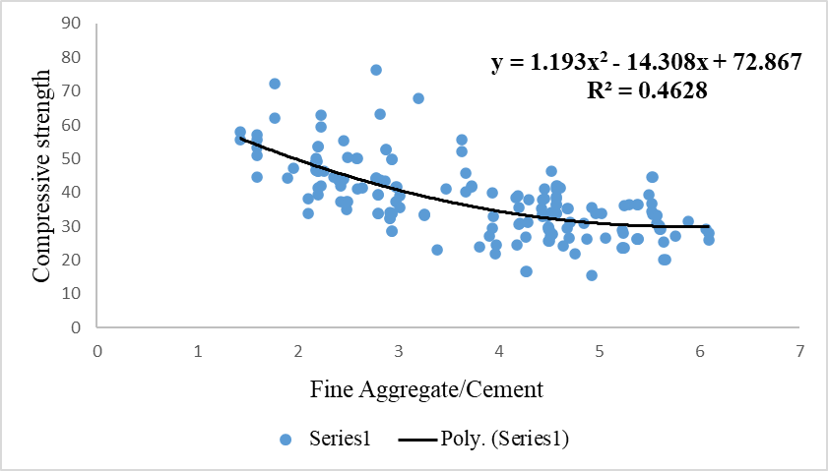

**Fig No. 3.17 Fine Aggregate/Cement Vs. Compressive strength**

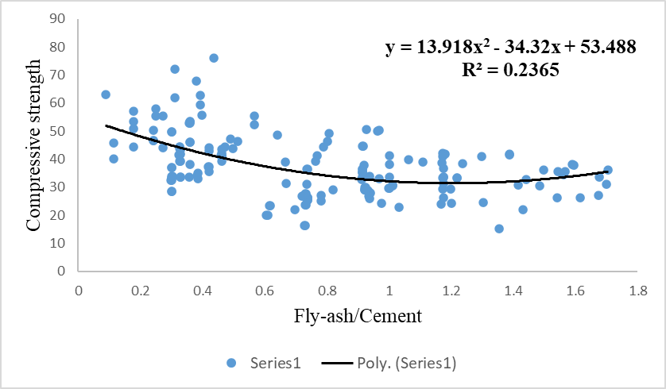

**Fig No. 3.18 Fly-ash/Cement Vs. Compressive strength**

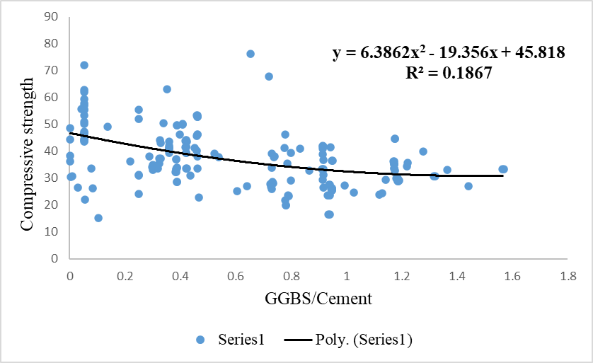

**Fig No. 3.19 GGBS/Cement Vs. Compressive strength**

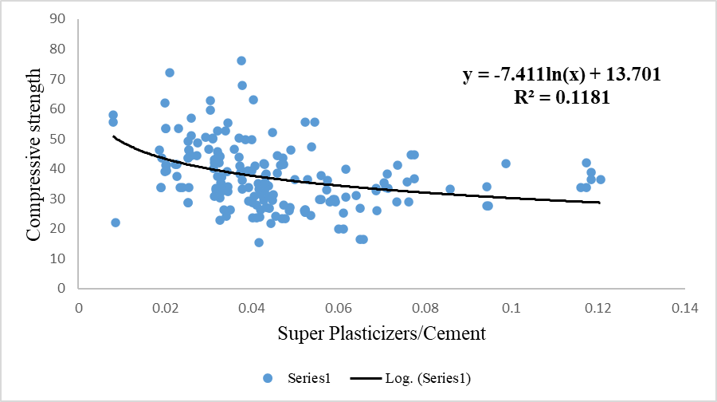

**Fig No. 3.20 Super Plasticizers/Cement Vs. Compressive strength**

1. Mix proportion containing water content, cement content, coarse aggregates, fine aggregates –

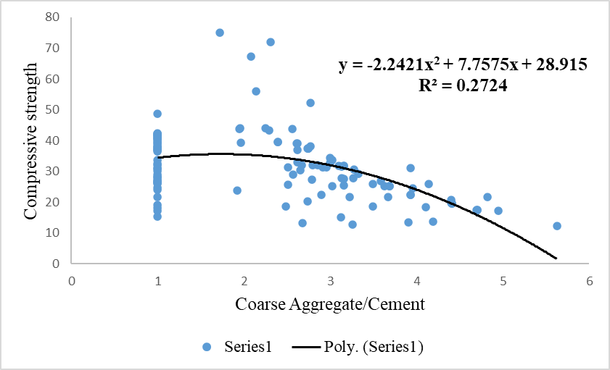

**Fig No. 3.21 Coarse Aggregate/Cement Vs. Compressive strength**

**Fig No. 3.22 Water/Cement Vs. Compressive strength**

**Fig No. 3.23 Fine Aggregate/Cement Vs. Compressive strength**

1. Mix proportion containing water content, cement content, coarse aggregates, fine aggregates, GGBS –

**Fig No. 3.24 Water/Cement Vs. Compressive strength**

**Fig No. 3.25 Coarse Aggregate/Cement Vs. Compressive strength**

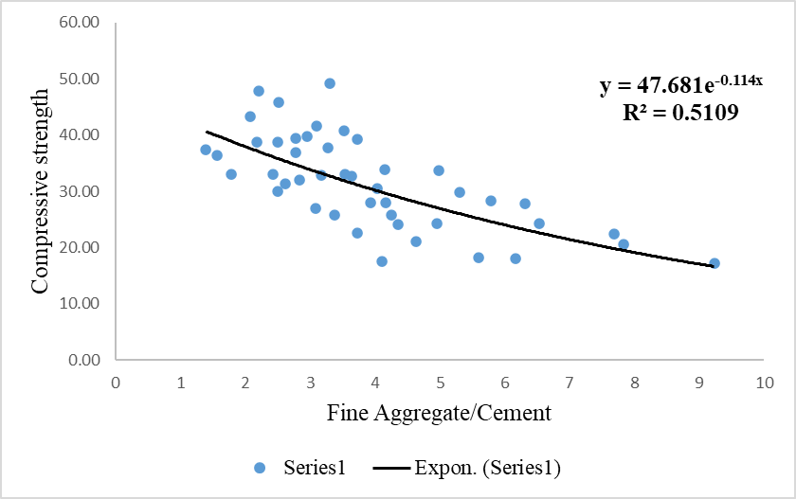

**Fig No. 3.26 Fine Aggregate/Cement Vs. Compressive strength**

**Fig No. 3.27 GGBS/Cement Vs. Compressive strength**

* 1. **DATA COLLECTION:**

Data was collected from 10 different world-wide sources –

* 1. RMC Plant located in Satara.
  2. Data from AI Model for Concrete- Taiwan
  3. Data from University of Melbourne, Australia.
  4. Tikrit Publication Source of Data, Iraq.
  5. International Journal of Concrete Structures and Materials. (Source – Korea)
  6. R. Springer. (Source – Japan)
  7. ACI Method of Concrete Mix Design Parametric Study. (Source – Singapore)
  8. *International Journal of Engineering Research and Technology,* Lucknow.
  9. Is 10262 – 2019.
  10. *Universal Journal of Engineering Science.* Libya,North Africa.

**SUMMARY:**

This chapter presents detailed information of methodology, mix proportions used, sensitivity analysis, data collection, step by step execution for formulation. Next chapter deals with results and discussion of Modified – Dimensional Analysis.

**CHAPTER 4: RESULTS AND DISCUSSIONS**

* 1. **INTRODUCTION:**

In this present research work study of 6 mix proportions to predict compressive strength of concrete was carried out. The results generated through M – DA in form of equations for these 6 mix proportions, is discussed in this chapter in detailed format. The results are validated through statistical parameters.

* 1. **RESULTS AND VALIDATION THROUGH STATISTICAL PARAMETERS:**

As per the **step – ix**, mentioned in section **3.4.**, below formulations were generated using M – DA.

1. **Concrete mix containing Water, Cement, Coarse Aggregates, Fine Aggregates, Fly Ash, Super Plasticizers were used in this formulation-**

Data:

Total Dataset – 140, Dataset used for training- 6 (4.29 percent of total dataset)

Dataset used for testing – 134 (95.71 percent of total dataset)

$$CS at 28 days= \left(Grade\right)\left(0.78\right){\left[\frac{water}{cement}\right]}^{-0.18}{\left[\frac{Coarse Aggregates}{cement}\right]}^{0.069}{\left[\frac{Fine Aggregates}{cement}\right]}^{-0.055}$$

$${\left[\frac{Fly ash}{cement}\right]}^{0.152}{\left[\frac{Super Platicizers}{cement}\right]}^{-0.09}$$

Performance measures of the model-

1. Average of ratio of measured by experimentation to predicted by M – DA model = 1.01 Explanation - It denotes what is the average value of measured/predicted parameter for total dataset, if the value is 1 that means the average value model is predicting are close to measured values.
2. Standard deviation of ratio of measured by experimentation to predicted by M – DA model = 0.10

It measures the distance of farthest point from the mean or average value of measured/predicted parameter for total dataset (range), closer the value to zero it denotes model will have predicted value close to measured values.

1. R square of ratio of measured by experimentation to predicted by M – DA model = 0.96

It is statistical measure of how close the data are to the fitted regression line; it lies in range 0 to 1. 0 indicates that the model explains none of variability of total dataset around its mean, 1 indicates that model explains all variability of respective data around its mean. (Accuracy of the model)

**Fig No. 4.1 Predicted Vs Measured**

1. **Concrete mix containing water, cement, Coarse Aggregates, Fine Aggregates, GGBS, Super Plasticizers were used in this formulation-**

Data:

Total Dataset – 101, Dataset used for training- 6 (5.95 percent of total dataset)

Dataset used for testing – 95 (94.05 percent of total dataset)

$$CS at 28 days= \left(Grade\right)\left(4.13\right){\left[\frac{water}{cement}\right]}^{0.47}{\left[\frac{Coarse Aggregates}{cement}\right]}^{-0.434}{\left[\frac{Fine Aggregates}{cement}\right]}^{-0.1065}$$

$${\left[\frac{GGBS}{cement}\right]}^{-0.02}{\left[\frac{Super Platisizers}{cement}\right]}^{0.159}$$

Performance measures of the model-

1. Average of ratio of measured by experimentation to predicted by M – DA model = 1.04
2. Standard deviation of ratio of measured by experimentation to predicted by M – DA model = 0.11
3. R square of ratio of measured by experimentation to predicted by M – DA model = 0.94

**Fig No. 4.2 Predicted Vs. Measured**

1. **Concrete mix containing water, cement, Coarse Aggregates, Fine Aggregates, Super Plasticizers were used in this formulation-**

Data:

Total Dataset – 40, Dataset used for training- 5 (12.5 percent of total dataset)

Dataset used for testing – 35 (87.5 percent of total dataset)

$$CS at 28 days= \left(Grade\right)\left(0.657\right){\left[\frac{water}{cement}\right]}^{-0.050}{\left[\frac{Coarse Aggregates}{cement}\right]}^{-0.00017}$$

$${\left[\frac{Fine Aggregates}{cement}\right]}^{0.088}{\left[\frac{Super Platisizers}{cement}\right]}^{-0.11}$$

Performance measures of the model-

1. Average of ratio of measured by experimentation to predicted by M – DA model = 0.95
2. Standard deviation of ratio of measured by experimentation to predicted by M – DA model = 0.09
3. R square of ratio of measured by experimentation to predicted by M – DA model = 0.95

**Fig No. 4.3 Predicted Vs. Measured**

1. **Concrete mix containing water, cement, Coarse Aggregates, Fine Aggregates, Fly Ash, GGBS, Super Plasticizers were used in this formulation-**

Data:

Total Dataset – 181, Dataset used for training- 7 (3.87 percent of total dataset)

Dataset used for testing – 174 (96.13 percent of total dataset)

$$CS at 28 days= \left(Grade\right)\left(1.36\right){\left[\frac{water}{cement}\right]}^{-0.04}{\left[\frac{Coarse Aggregates}{cement}\right]}^{0.09}{\left[\frac{Fine Aggregates}{cement}\right]}^{-0.21}$$

$${\left[\frac{GGBS}{cement}\right]}^{-0.012}{\left[\frac{Super Platisizers}{cement}\right]}^{0.0456}{\left[\frac{Fly ash}{cement}\right]}^{0.06}$$

Performance measures of the model-

1. Average of ratio of measured by experimentation to predicted by M – DA model = 1.07
2. Standard deviation of ratio of measured by experimentation to predicted by M – DA model = 0.09
3. R square of ratio of measured by experimentation to predicted by M – DA model = 0.96

**Fig No. 4.4 Predicted Vs. Measured**

1. **Concrete mix containing water, cement, Coarse Aggregates, Fine Aggregates were used in this formulation –**

Data:

Total Dataset – 121, Dataset used for training- 4 (3.30 percent of total dataset)

Dataset used for testing – 117 (96.69 percent of total dataset)

$CS at 28 days= \left(Grade\right)\left(0.7124\right){\left[\frac{water}{cement}\right]}^{-0.149}{\left[\frac{Coarse Aggregates}{cement}\right]}^{0.0631}{\left[\frac{Fine Aggregates}{cement}\right]}^{0.301}$

Performance measures of the model-

1. Average of ratio of measured by experimentation to predicted by M – DA model = 1.07
2. Standard deviation of ratio of measured by experimentation to predicted by M – DA model = 0.14
3. R square of ratio of measured by experimentation to predicted by M – DA model = 0.92

**Fig No. 4.5 Predicted Vs. Measured**

1. **Concrete mix containing water, cement, Coarse Aggregates, Fine Aggregates, GGBS were used in this formulation-**

Data:

Total Dataset – 45, Dataset used for training- 5 (11.11 percent of total dataset)

Dataset used for testing – 40 (88.88 percent of total dataset)

$$CS at 28 days= \left(Grade\right)\left(0.667\right){\left[\frac{water}{cement}\right]}^{0.088}{\left[\frac{Coarse Aggregates}{cement}\right]}^{0.63}{\left[\frac{Fine Aggregates}{cement}\right]}^{-0.408}$$

$${\left[\frac{GGBS}{cement}\right]}^{-0.077}$$

Performance measures of the model-

1. Average of ratio of measured by experimentation to predicted by M – DA model = 1.03
2. Standard deviation of ratio of measured by experimentation to predicted by M – DA model = 0.07
3. R square of ratio of measured by experimentation to predicted by M – DA model = 0.93

**Fig No. 4.6 Predicted Vs. Measured**

**CHAPTER 5: CONCLUSION**

* 1. **INTRODUCTION:**

In the current industry, predicting compressive strength for 28-days for commonly used mix proportions can help practicing engineers in decision making. In current research work 6 equations have been derived in order to predict compressive strength of concrete based on collected data. From section 4 it is evident that prediction through M – DA methodology is effective to wide range of concrete grade from M10 to M80. This methodology gives an additional advantage of incorporating the dimensional homogeneity to derived formulation. Based on the entire research work following conclusions can be derived.

* 1. **KEY OBSERVATIONS FROM SENSITIVITY ANALYSIS:**

Each mix proportion had different trends. Which denotes that prediction for each mix proportion demands different equation/formulation.

1. The order of sensitivity for mix proportion i. from 3.5. is:
2. Water/Cement
3. Coarse aggregates/Cement
4. Fine aggregates/Cement
5. Fly ash/Cement
6. Super plasticizers/Cement
7. The order of sensitivity for this mix proportion ii. from 3.5. is:
8. Water/Cement
9. Fine aggregates/Cement
10. Coarse aggregates/Cement
11. GGBS/Cement
12. Super plasticizers/Cement
13. The order of sensitivity for this mix proportion iii. from 3.5. is:
14. Water/Cement
15. Coarse aggregates/Cement
16. Fine aggregates/Cement
17. Super plasticizers/Cement
18. The order of sensitivity for this mix proportion iv. from 3.5. is:
19. Water/Cement
20. Fine aggregates/Cement
21. Coarse aggregates/Cement
22. Fly ash/Cement
23. GGBS/Cement
24. Super plasticizers/Cement
25. The order of sensitivity for this mix proportion v. from 3.5. is:
26. Water/Cement
27. Fine aggregates/Cement
28. Coarse aggregates/Cement

1. The order of sensitivity for this mix proportion vi. from 3.5. is:
2. Fine aggregates/Cement
3. Coarse aggregates/Cement
4. Water/Cement
5. GGBS/Cement
   1. **RELATIONSHIPS IDENTIFIED BETWEEN CONCRETE INGREDIENTS AND COMPRESSIVE STRENGTH OF CONCRETE:**
      1. **Concrete Mix Containing Water, Cement, Coarse Aggregates, Fine Aggregates, Fly Ash, Super Plasticizers-**

Comments on the formula derived in 1. of section 4.2. –

1. Derived equation for compressive strength is dimensional homogenous.
2. Compressive strength at 28 days is inversely proportional to ratio of water to cement.
3. Compressive strength at 28 days is directly proportional to ratio of coarse aggregate to cement.
4. Compressive strength at 28 days is inversely proportional to ratio of fine aggregate to cement.
5. Compressive strength at 28 days is directly proportional to ratio of fly ash to cement.
6. Compressive strength at 28 days is inversely proportional to ratio of super plasticizer to cement.
7. Compressive strength at 28 days is directly proportional to cement content as .
   * 1. **Concrete Mix Containing Water, Cement, Coarse Aggregates, Fine Aggregates, GGBS, Super Plasticizers-**

Comments on the formula derived in 2. of section 4.2. –

1. Derived equation for compressive strength is dimensional homogenous.
2. Compressive strength at 28 days is directly proportional to ratio of water to cement.
3. Compressive strength at 28 days is inversely proportional to ratio of coarse aggregate to cement.
4. Compressive strength at 28 days is inversely proportional to ratio of fine aggregate to cement.
5. Compressive strength at 28 days is inversely proportional to ratio of GGBS to cement.
6. Compressive strength at 28 days is directly proportional to ratio of super plasticizer to cement.
7. Compressive strength at 28 days is inversely proportional to water content as .
   * 1. **Concrete Mix Containing Water, Cement, Coarse Aggregates, Fine Aggregates, Super Plasticizers-**

Comments on the formula derived in 3. of section 4.2. –

1. Derived equation for compressive strength is dimensional homogenous.
2. Compressive strength at 28 days is inversely proportional to ratio of water to cement.
3. Compressive strength at 28 days is inversely proportional to ratio of coarse aggregate to cement.
4. Compressive strength at 28 days is directly proportional to ratio of fine aggregate to cement.
5. Compressive strength at 28 days is inversely proportional to ratio of super plasticizer to cement.
6. Compressive strength at 28 days is directly proportional to water content as .
   * 1. **Concrete Mix Containing Water, Cement, Coarse Aggregates, Fine Aggregates, Fly Ash, GGBS, Super Plasticizers-**

Comments on the formula derived in 4. of section 4.2. –

1. Derived equation for compressive strength is dimensional homogenous.
2. Compressive strength at 28 days is inversely proportional to ratio of water to cement.
3. Compressive strength at 28 days is directly proportional to ratio of coarse aggregate to cement.
4. Compressive strength at 28 days is inversely proportional to ratio of fine aggregate to cement.
5. Compressive strength at 28 days is directly proportional to ratio of fly ash to cement.
6. Compressive strength at 28 days is inversely proportional to ratio of GGBS to cement.
7. Compressive strength at 28 days is directly proportional ratio of super plasticizer to cement.
8. Compressive strength at 28 days is directly proportional to water content as .
   * 1. **Concrete Mix Containing Water, Cement, Coarse Aggregates, Fine Aggregates-**

Comments on the formula derived in 5. of section 4.2. –

1. Derived equation for compressive strength is dimensional homogenous.
2. Compressive strength at 28 days is inversely proportional to ratio of water to cement.
3. Compressive strength at 28 days is directly proportional to ratio of coarse aggregate to cement.
4. Compressive strength at 28 days is directly proportional to ratio of fine aggregate to cement.
5. Compressive strength at 28 days is inversely proportional to water content as .
   * 1. **Concrete Mix Containing Water, Cement, Coarse Aggregates, Fine Aggregates, GGBS-**

Comments on the formula derived in 6. of section 4.2. –

1. Derived equation for compressive strength is dimensional homogenous.
2. Compressive strength at 28 days is directly proportional to ratio of water to cement.
3. Compressive strength at 28 days is directly proportional to ratio of coarse aggregate to cement.
4. Compressive strength at 28 days is inversely proportional to ratio of fine aggregate to cement.
5. Compressive strength at 28 days is inversely proportional to ratio of GGBS to cement.
6. Compressive strength at 28 days is inversely proportional to water content as $( {cement content)}^{-0.233}$.
   1. **NOVELTY OF THE MODELS DERIVED:**
7. The equations generated have dimensional homogeneity.
8. Formulae are user friendly and can be used by any engineer without any skill.
9. The methodology (M – DA) can be used for any concrete mix.
10. The result obtained from the developed methodology can help a practicing engineer for early decision making in construction work, as this methodology is universal in nature.
    1. **FUTURE SCOPE:**

This methodology can be further applicable to any physical or chemical phenomenon which requires dimensional homogeneity such as prediction in corrosion of steel parameters, metrological measurements, hydrology measurements, etc.

**REFERENCE**

Butterfield, R. (1999). “Dimensional analysis for geotechnical engineers.” *Geotechnique*, 49(3), 375-366.

Corrade, M. & Carpinteri, A. (2009). “Dimensional Analysis of over-reinforced concrete beams in bending”. *Journal of Engineering Mechanics*, Vol. 135, pp. 221-229.

D. Esmaili and N. Hataf (2013). “Determination of ultimate load Capacity of conical and pyramidal shell foundations using dimensional analysis.” IJST, Transactions of Civil Engineering, Vol. 37, No. C+, pp 423-435.

D. R. Phatak and H. B. Dhonde, (2003). “Dimensional Analysis of Reinforcement Concrete Beams Subjected to Pure Torsion.” *Journal of Structural Engineering*

D. R. Phatak, and H. B. Dhonde (1999). “Discussion of ‘Behaviour of Five Large Spread Footing in Sand.’ By Jean-Lous Briaud and Robert Gibbens.” *J. Geotech. Geoenviron. Eng*., 126(10), 940-942

D. R. Phatak and N. P. Deshpande, (2005). “Prediction of 28-days compressive strength of 53-grade using dimensional analysis.” *Journal of Materials in Civil Engineering*

Dr. Salim T. Yousif, Salwa M. Abdullah, (2009). “Artificial Neural Network Model for Predicting Compressive Strength of Concrete”. *Tikrit Journal of Eng. Sciences*

P.N. Modi and S.M. Seth, (1960). “Hydraulics and Fluid Mechanics including Hydraulics Machines”. *Rajsons Publication Pvt. Ltd*. Standard book house.

Musbah Guma Musbah, Allam Musbah Al Allam, Hosni Abdulruhman Saleh, Ibrahim Mousbah Ateeg. “Effects of Super plasticizing Admixtures on the Compressive Strength of Concrete”. *Universal Journal of Engineering Science. College of Technical Sciences, Bani Walid, 00218, Libya.*

Rachel Cook, Jonathan Lapeyre, Hongyan Ma and Aditya Kumar, (2019). “Prediction of Compressive Strength Concrete: Critical Comparison of Performance of a Hybrid Machine Learning Model with Standalone Models”. *Journal of Materials in Civil Engineering.*

Rajiv Banarjee, Md. Abi d Alam, Zeeshan Ahmad, (2015). “Study of Compressive Strength of Various Grades of Concrete using Different Sizes of Cubes”. *International Journal of Engineering Research & Technology*

Sangjun Park, (2012). “Study on the Fluidity and Strength Properties of High-Performance Concrete Utilizing Crushed Sand”. *International Journal of Concrete Structures and Materials.*

Tuan Ngyen, Tuan Ngo, (2018). “Compressive strength dataset of foamed/normal concrete for prediction model”. *The University of Melbourne. Dataset*

Yong‑Hyok Kim, Cho‑Bum Park, Byoung Il Choi, Tae Yong Shin, Yubin Jun4 and Jae Hong Kim, (2020). “Quantitative Measurement of Water Absorption of Coarse Lightweight Aggregates in Freshly‑Mixed Concrete”. *International Journal of Concrete Structures and Materials*

Z. Wadud, S. Ahmad, (2001). ACI Method of Concrete Mix Design: A Parametric Study. *The Eighth East Asia-Pacific Conference on Structural Engineering and Construction 5-7 December 2001, Nanyang Technological University, Singapore.*